Follow this video to install driver for USBasp

<https://www.youtube.com/watch?v=jgHIFWPUe_M>

You can download Zadig at <https://zadig.akeo.ie>

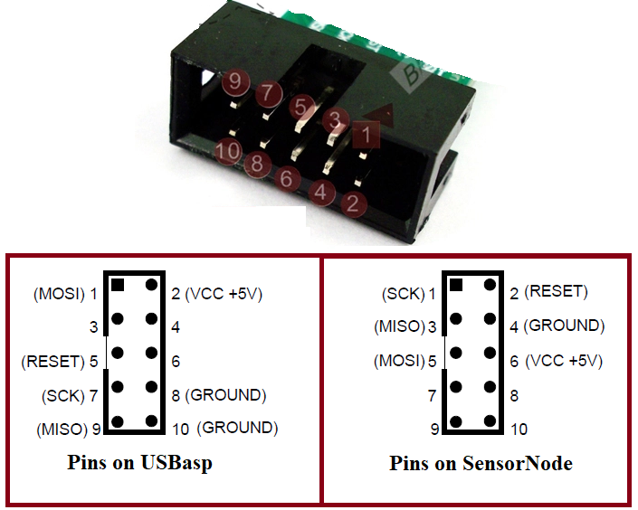

*Connect pin on USBasp to Sensor Node*

**MOSI > MOSI**

**MISO > MISO**

**SCK > SCK**

**RESET > RESET**

**VCC > VCC**

**GND > GND**

**Open Aruidno IDE and open .ino file (updated code).**

**Choose Board : Arduino Mega 2560 and Processor : ATmega2560**

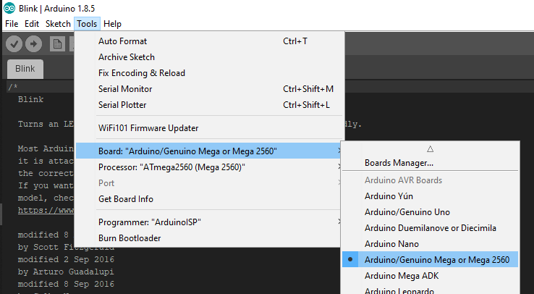

**Connect USBasp to computer**

**Choose Programmer : USBasp and Port COM**

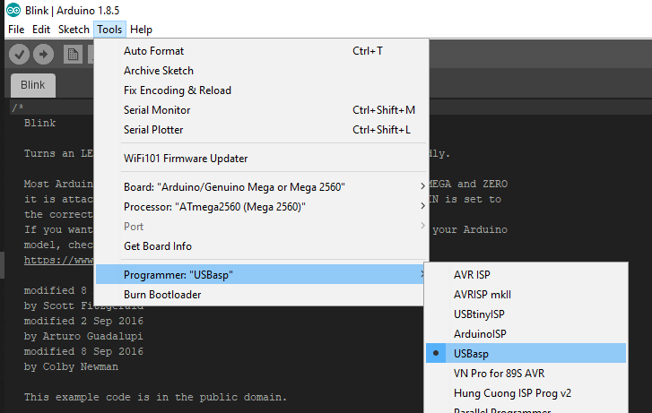

**Then click Upload to loading code for ATmega2560 on Sensor Node.**

